**Read evironment humidity and temperature with DHT11**

1. **Requirements**

* Use DHT11 sensor to read the temperature and humidity from environment
* Display the value of temperature and humidity to the Serial monitor

1. **The schematic**

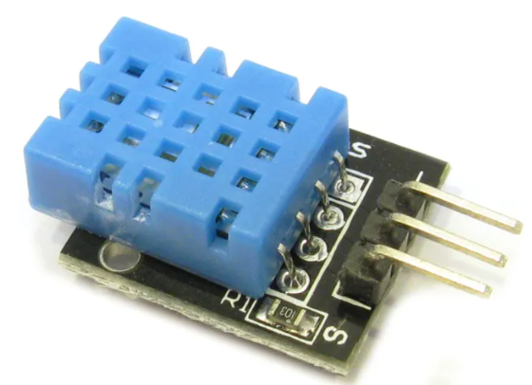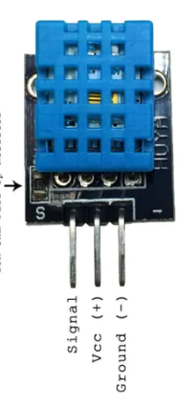

**DHT11**

DHT11 PIN:

The S pin : signal pin or data pin (in the below image, the data pin is connected to pin 2 on Uno board)

The “ - ” sign pin : GND pin

The midle pin : GCC (5V) pin

Some others pin layout of DHT11

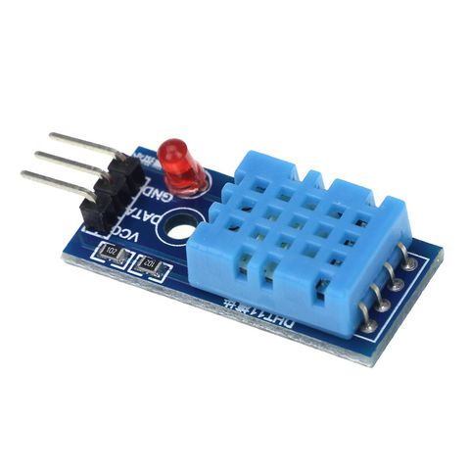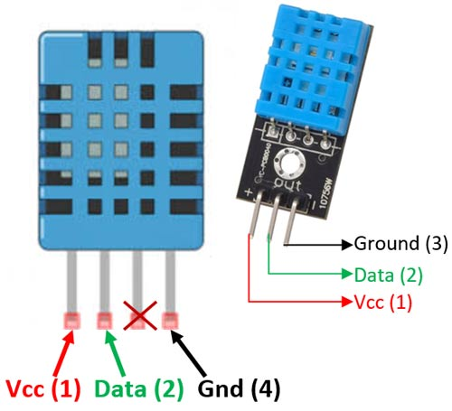

**Note: Check your device’s pin layout carefully before connecting**

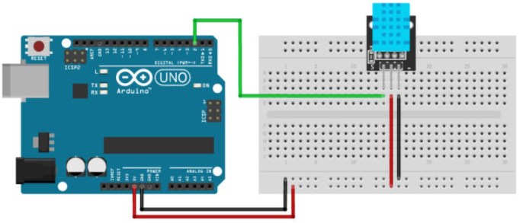

1. **Install DHT11 library first, Using Adafruit library (Install all)**

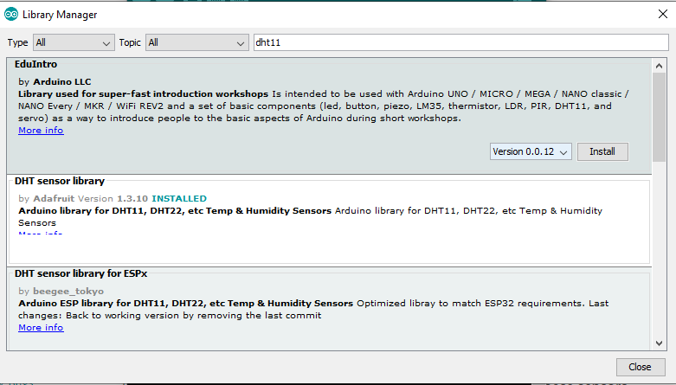

1. **Code the Sketch for test DHT**

#include "DHT.h"

#define DHTTYPE DHT11 // DHT 11

const int DHTPIN = 2;

DHT dht(DHTPIN, DHTTYPE);

void setup()

{

Serial.begin(9600);

dht.begin();

}

void loop()

{

float h = dht.readHumidity();

float t = dht.readTemperature();

Serial.print("Nhiet do: ");

Serial.println(t);

Serial.print("Do am: ");

Serial.println(h);

Serial.println();

delay(1000);

}